**Change man Package creation for implementations**

TSO CMN1

1(**BUILD**);1(**CREATE**)

Option **S** for filling less details

**Note -**

DK01- **814**

DK02-**817**

LV23- **Latvia**

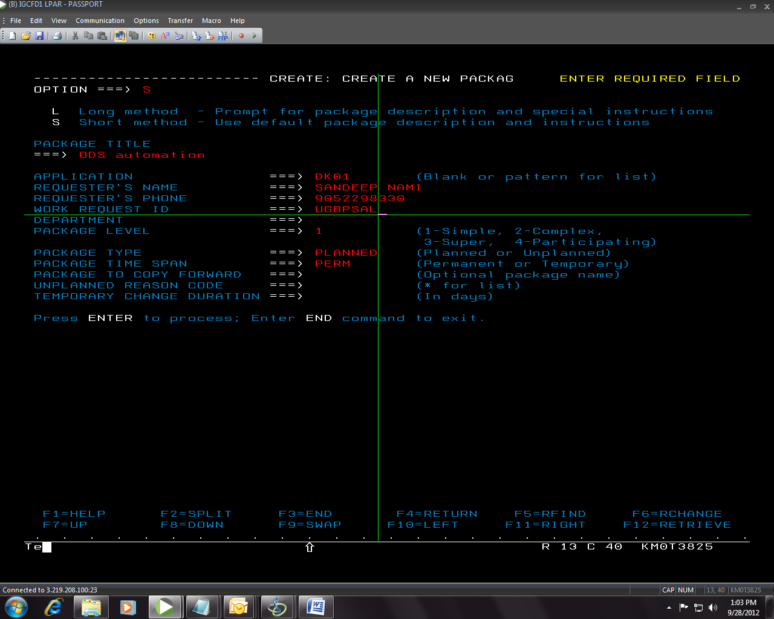

* NOW PRESS **ENTER** you WILL SEE BELOW

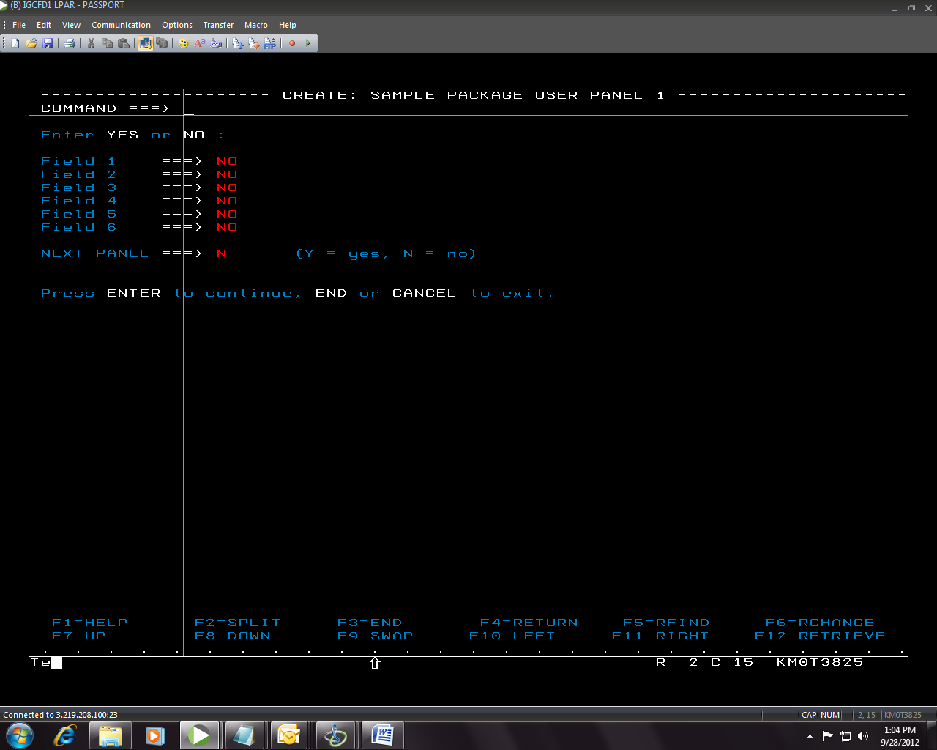

* NOW PRESS ENTER AGAIN

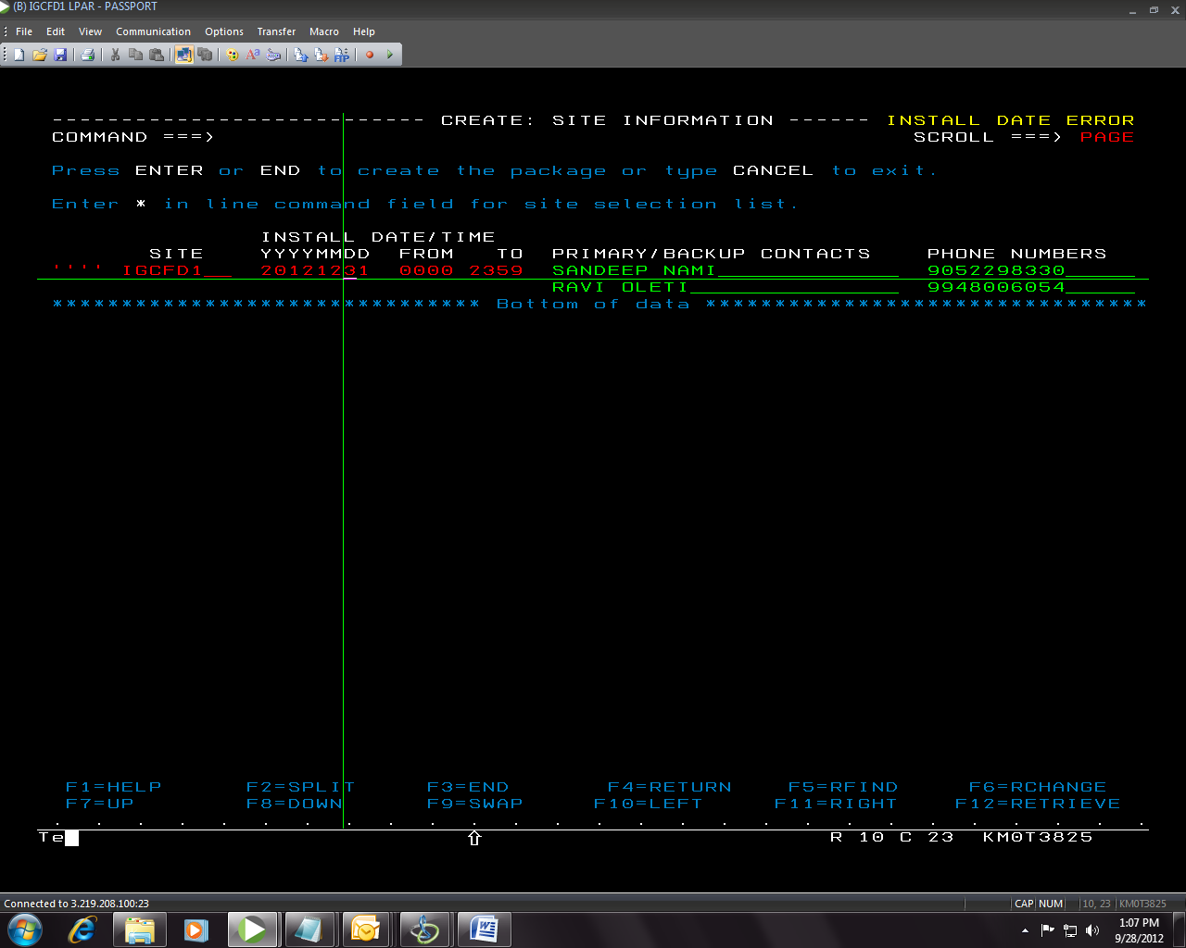

GIVE **INSTALL DATE** AS Year end

* Now press enter Then package will be created

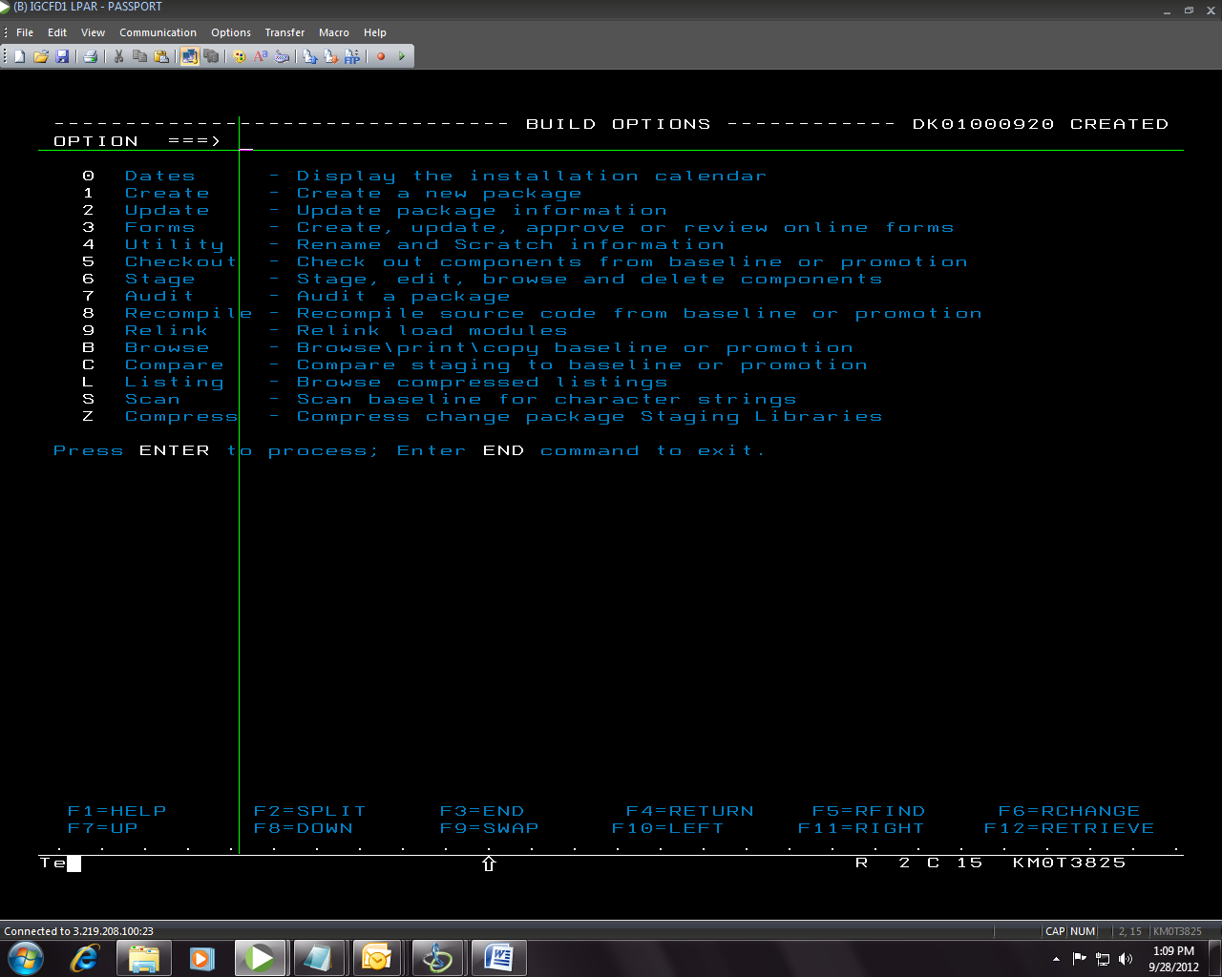

* Please note that you have to press **F3** only once now
* Now go to list the packages option i.e 5(List )
* Give your package id say DK01000920
* Now give **S2** before the package

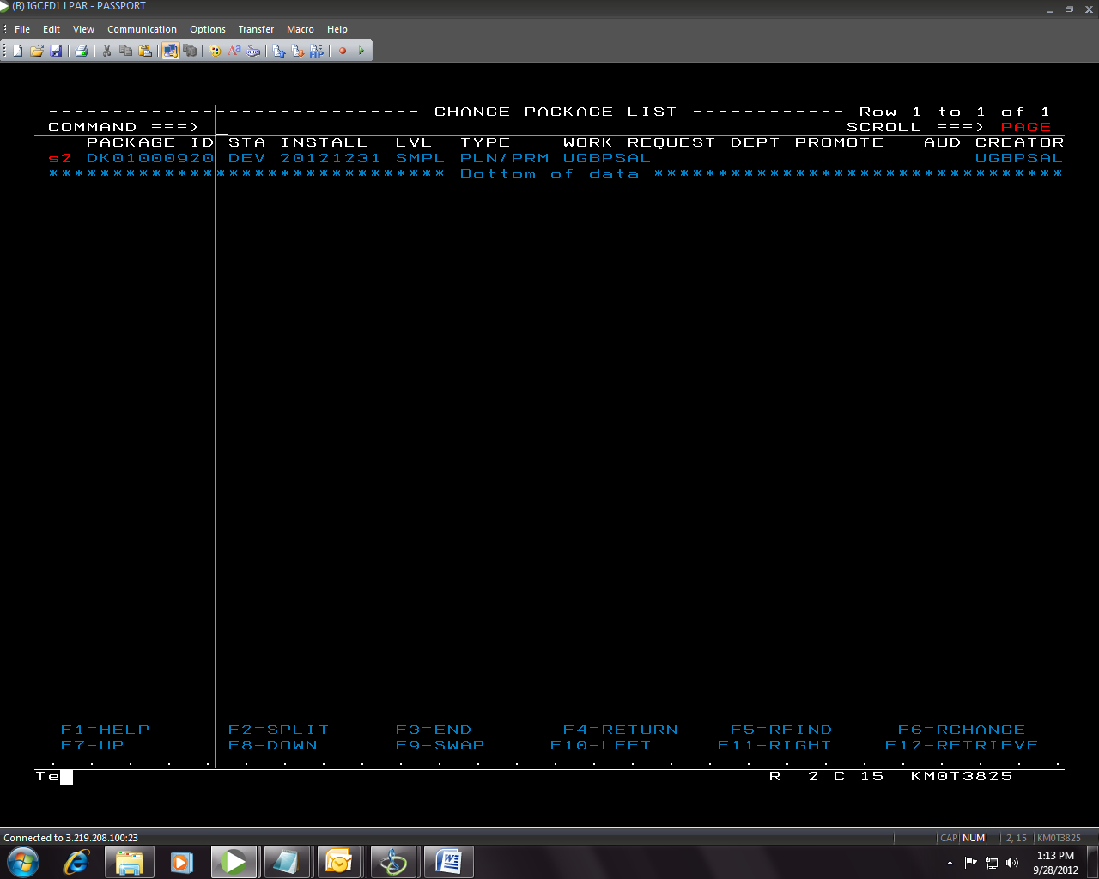

C1- checkout components

S1- Stage components

S2- browse components

R- RECOMPILE

V- VIEW

E-EDIT

* Now give **S1** before the package

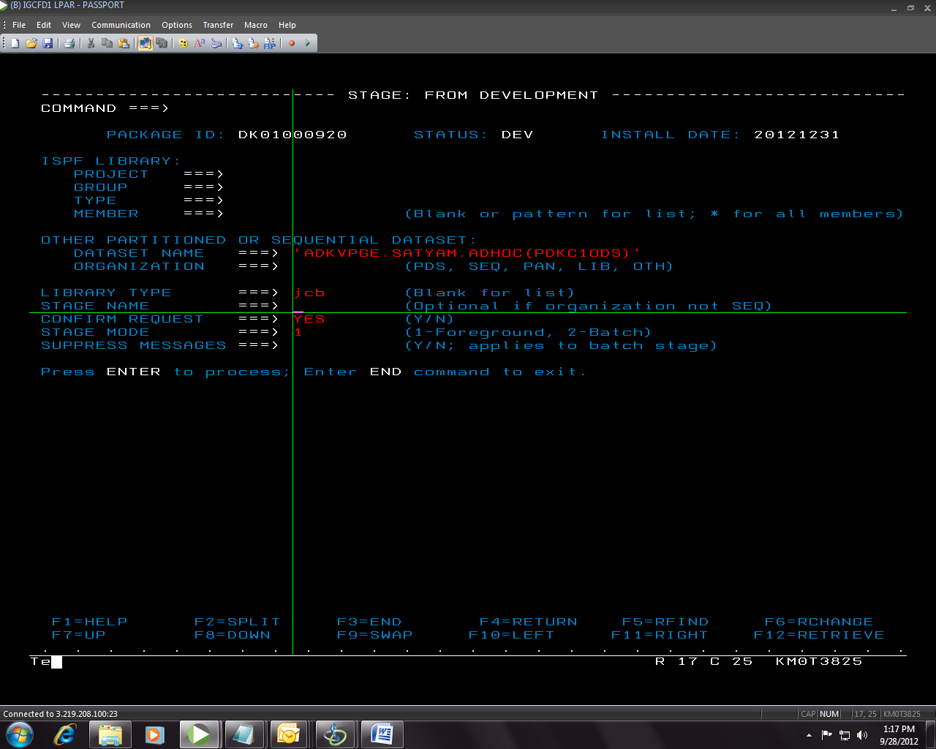

**Jcb**- since the staging code is JCL

Proc- **PRV**

Trams Parm- **PMR**

**EBR**- Trams enhancement

* Then press enter and add the following details in the screen

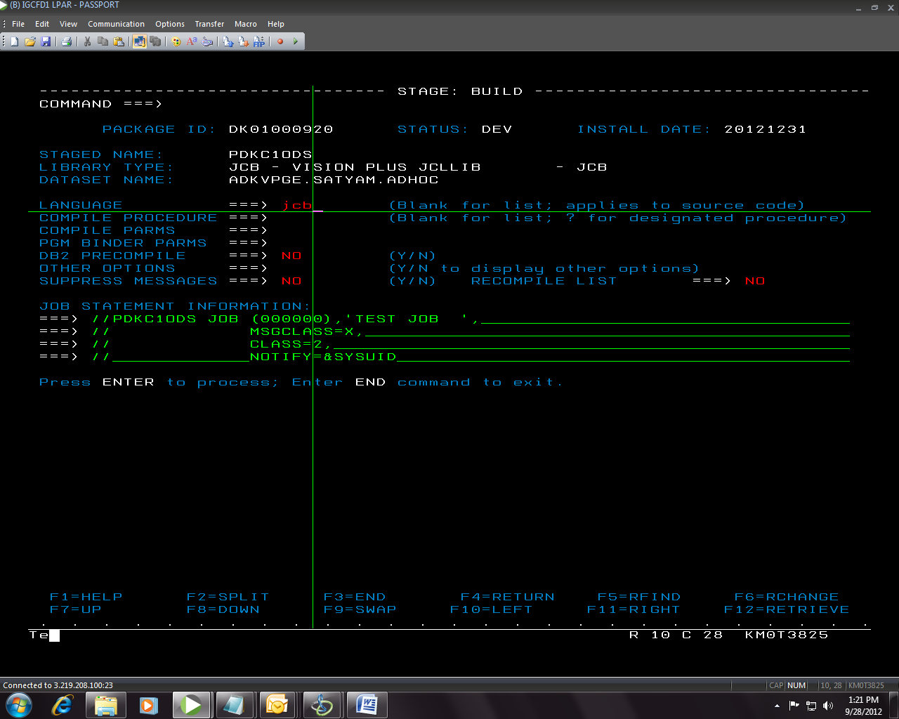

For

JCL- **JCB**

PARM-**PAR**

REXX- **PAR/PRV**

**Cobol – ENH(**for newly coded cobol**)**

**Proc- PRO**

* For **Library Type** we can give **PMC for rexx** related if we don’t know which module the rexx relates to
* 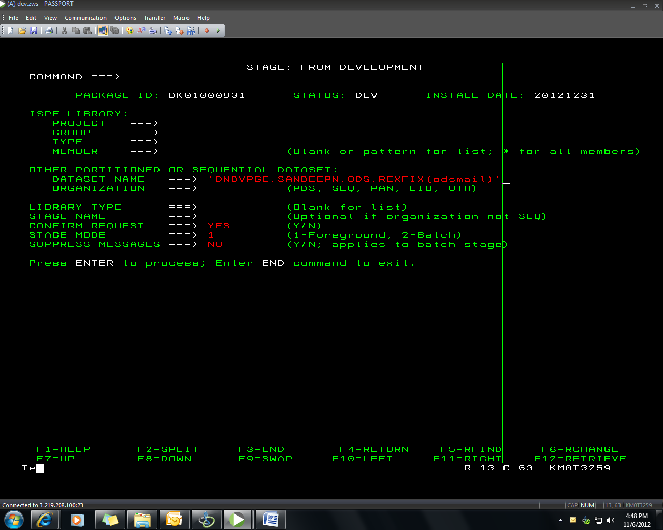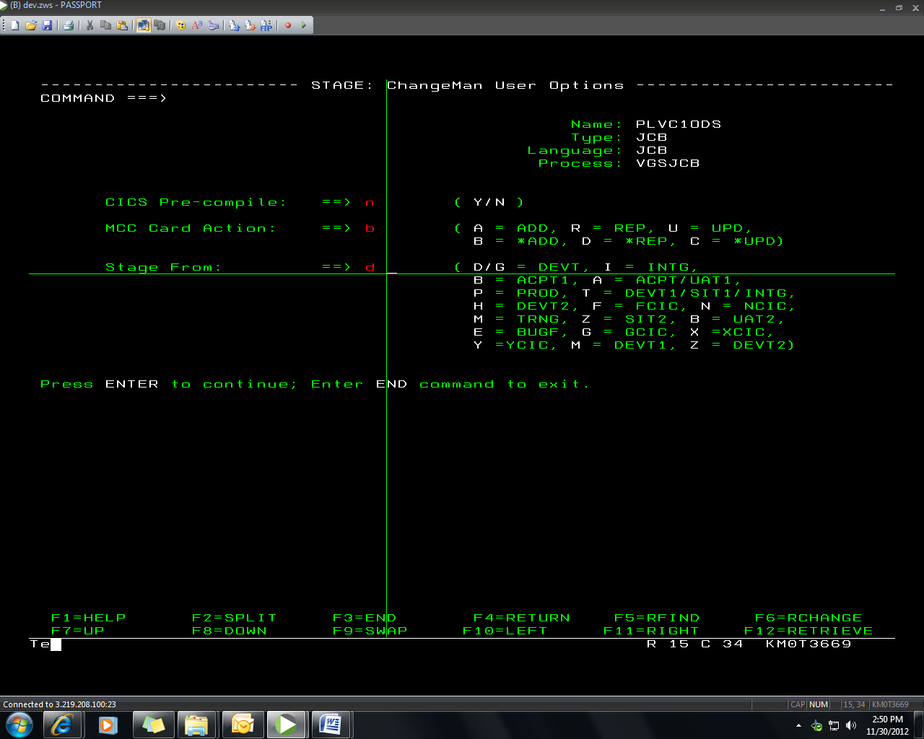

For production give

Stage From: ==> **p** -> FOR PARMS/Rexx

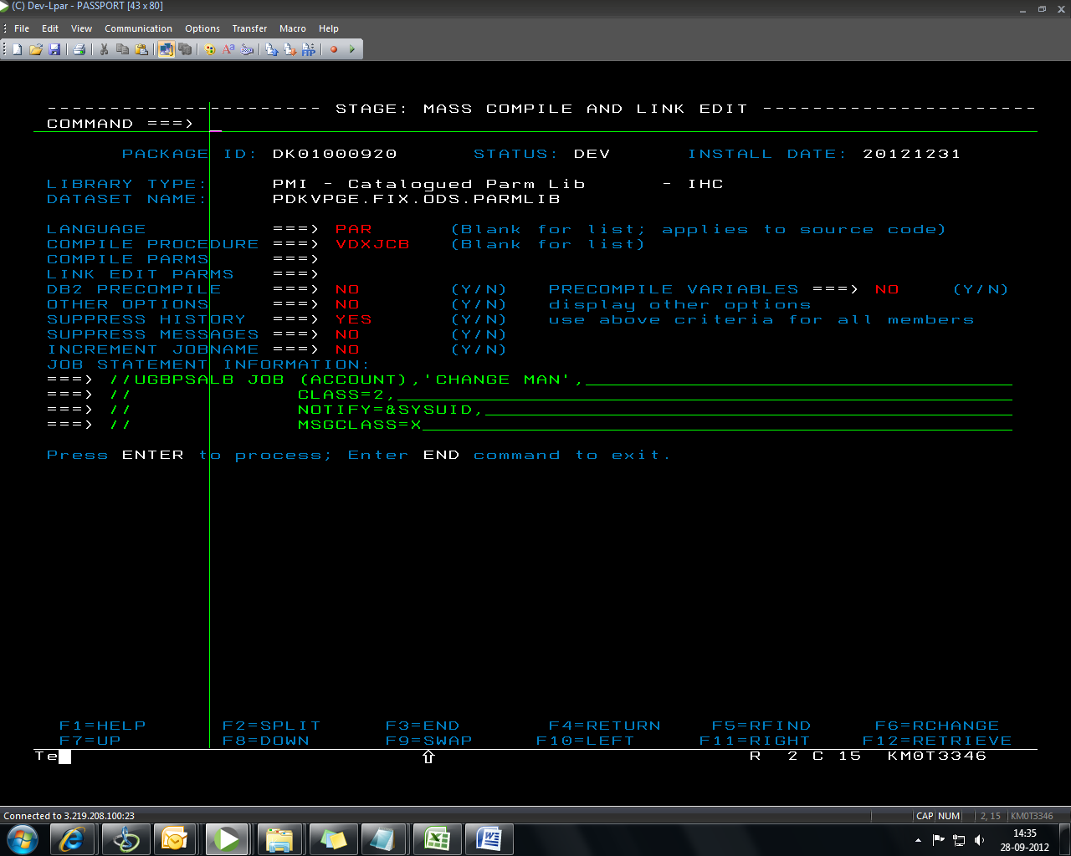

* For activating the rexx component

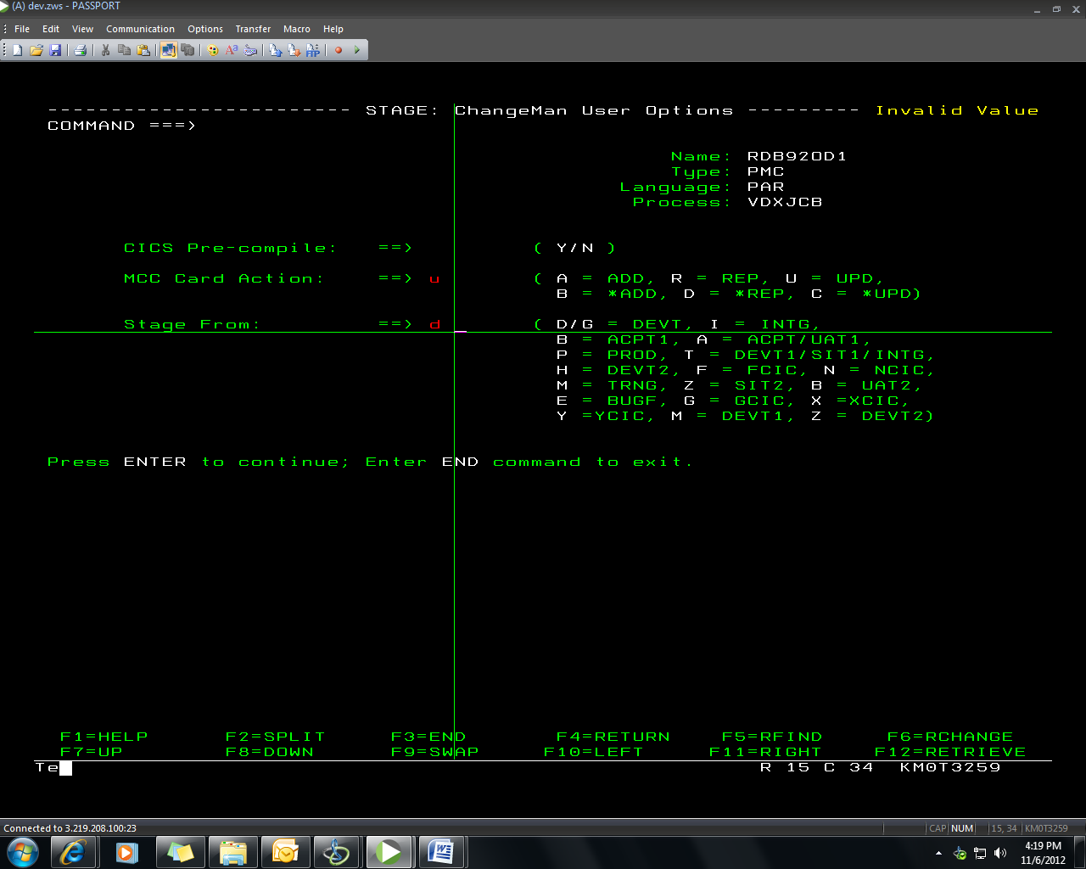

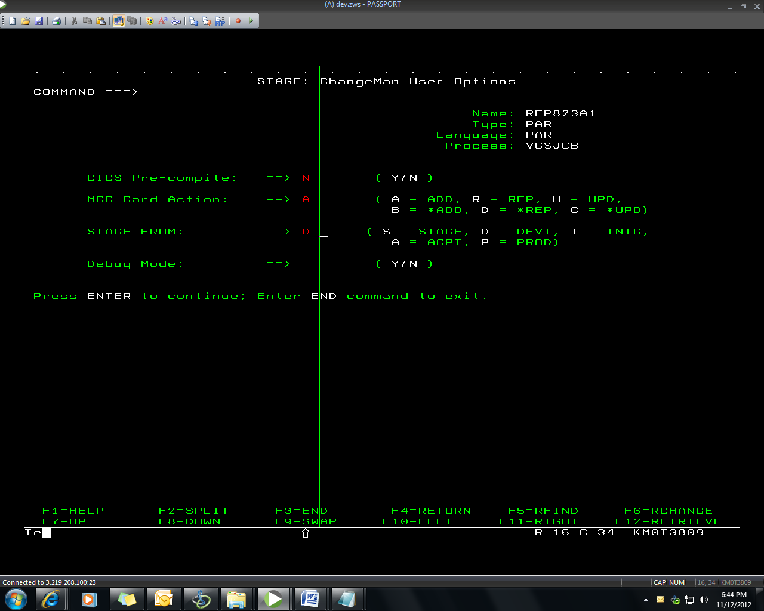

* If a Job already exists in production i.e when we try to stage an existing job in production we will get message **checkout enforced.**

For this we have to check out the code first by giving **C1** and then stage the changed JOB

Library Type: **JCB** (for JCL)

PRI (for Procs)

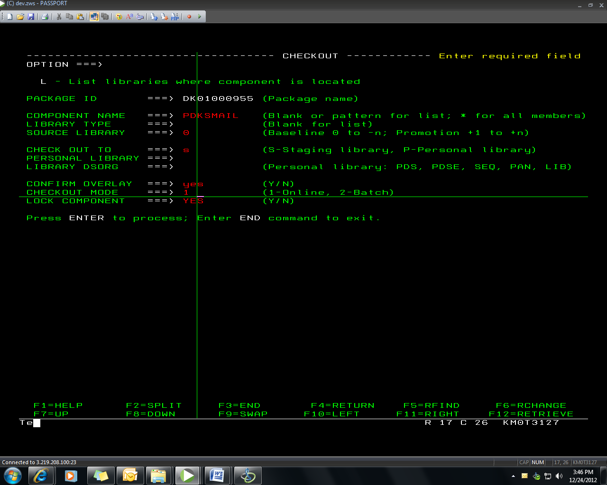**For Cobol code CHECKOUT especially in changeman**

**Displays** are not allowed.

So we have to write **PRDISPLAY** instead.

**IF/PERFORM/MOVE/COMPUTE/ADD/AND/OR/SET**

Positions must start from 12/16/20/24

Eg- cobol CHGMAN **DK01000963**

Options-

Unlock- **UC**

The Load of code will be present in **CHGMAN.DK011.STG.#000963.BAT**

When we load the cobol progarmme for the first time , we have to create control card and trigger

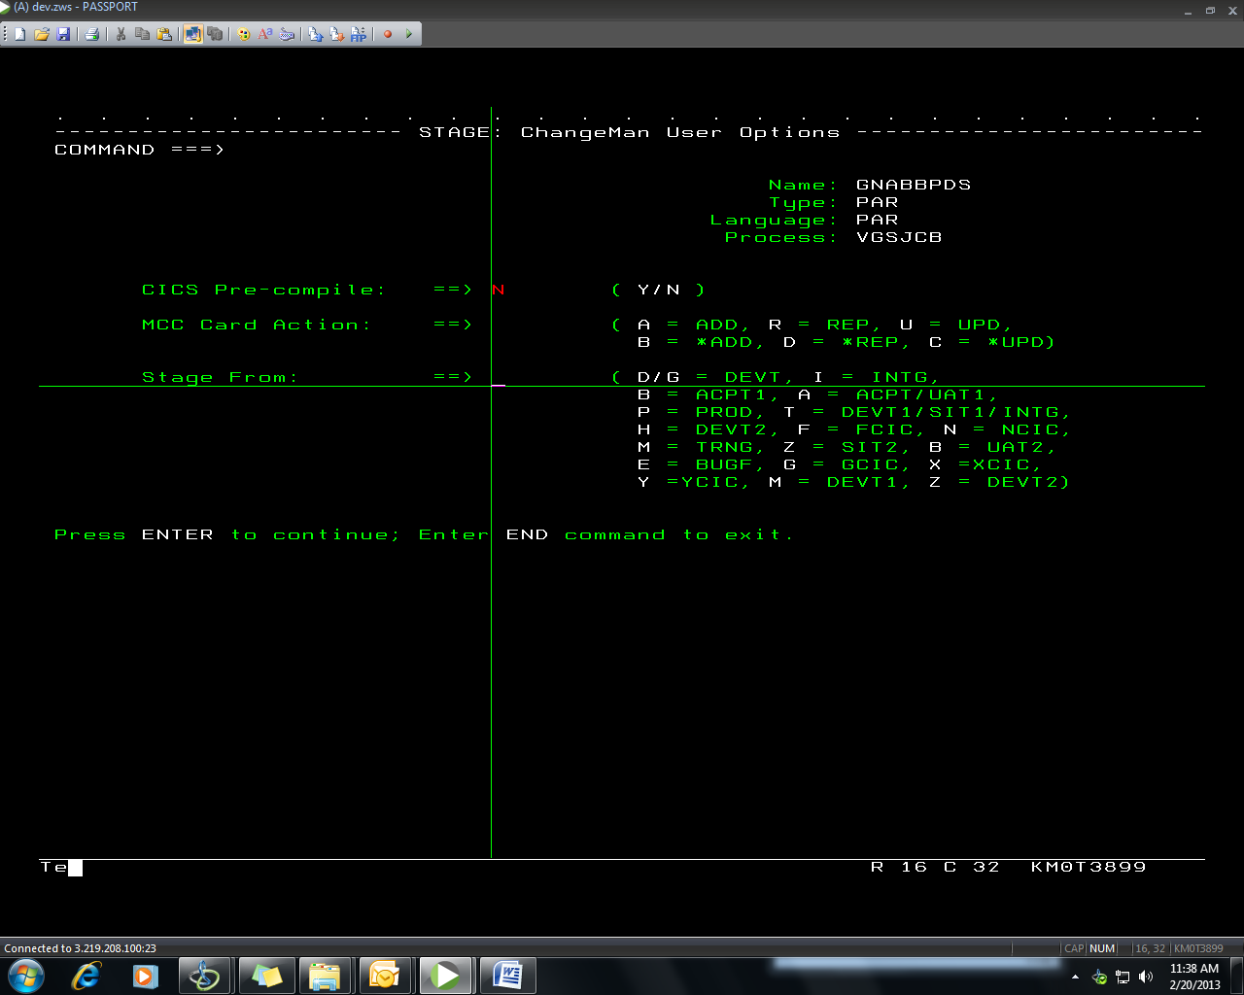

**MCC Card Action: ==>**

This parameter **is not needed** for **Parms,Procs and JCL**

**Change man options**

**R- recompile**

**S- stage/compile**

**Checkout component**

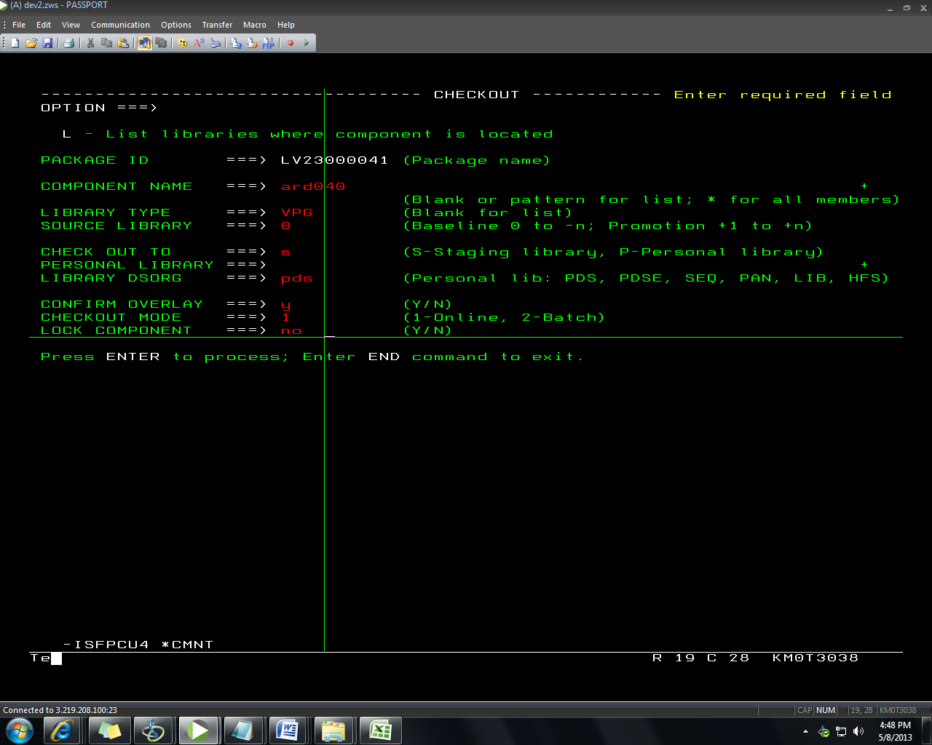

**Stage components**

**S1**- Stage components

**S** - compile the program

**INACTIVE COMPONENTS(INCOMP)**

If changemen componenent is inactive then give compile it again (**S**)

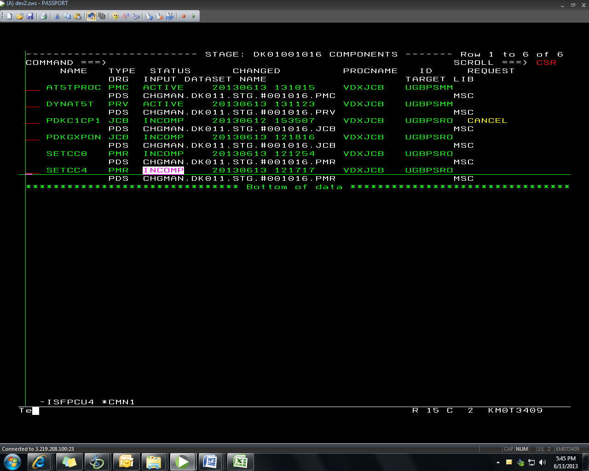

Press enter again

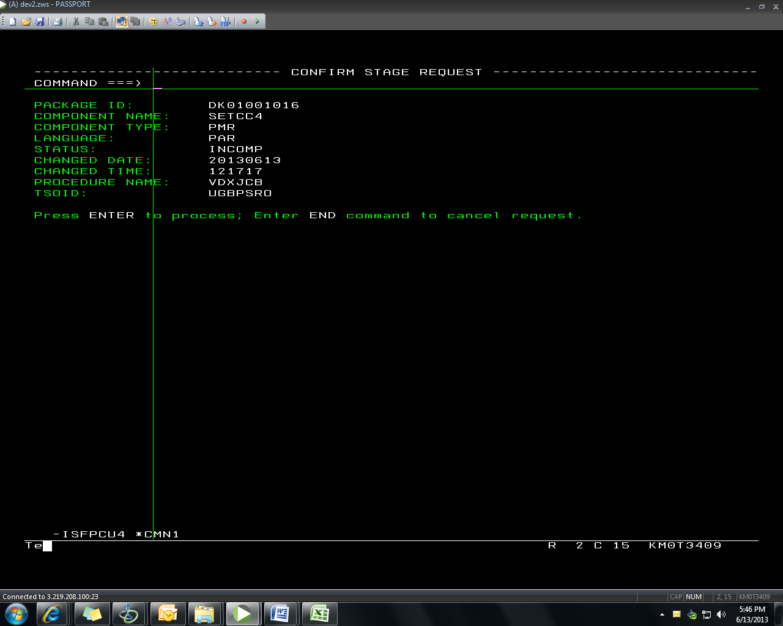

Press enter again

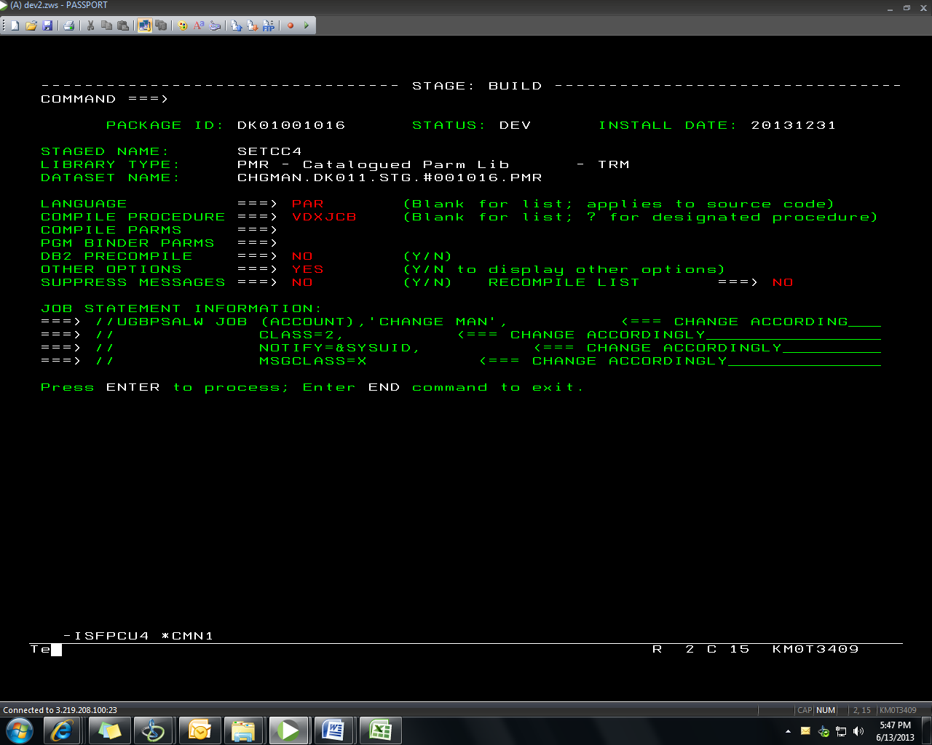

Give **P** before stage from:

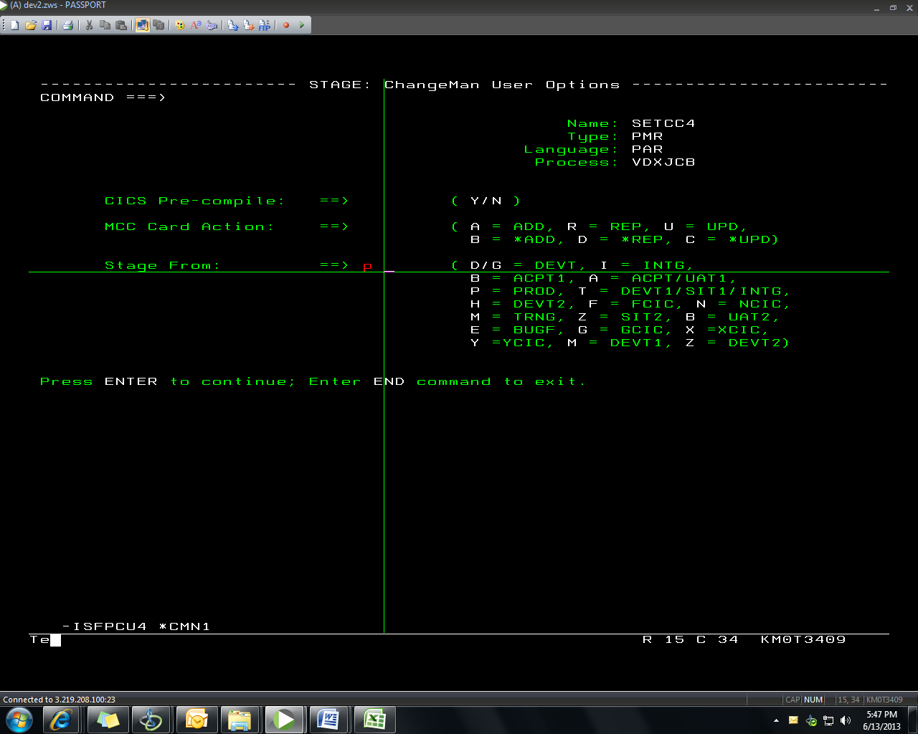

**Promote a package(PR)**

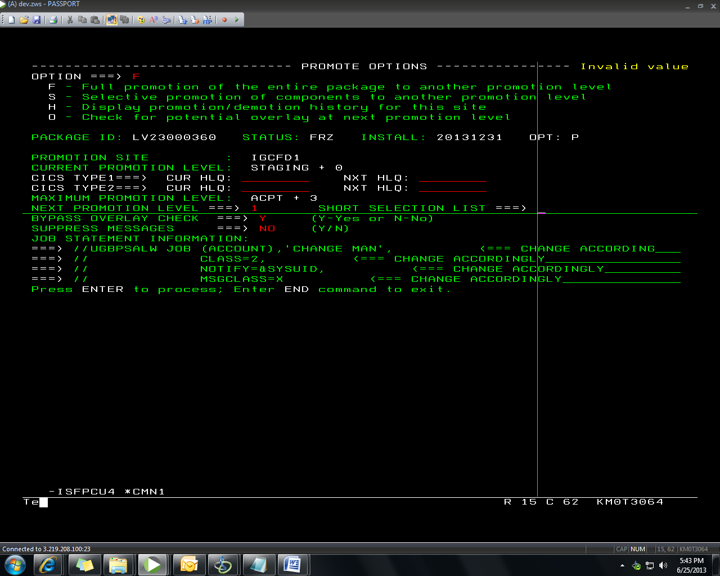

**Short selection List:** NA

**Demote the change package(DM)**

